Transparency: How E-Commerce Companies Are Taking the Risks Out Of Buying Online
And How Doorsey’s Transparent Homebuying Processes Make Buying or Selling A House a Breeze!
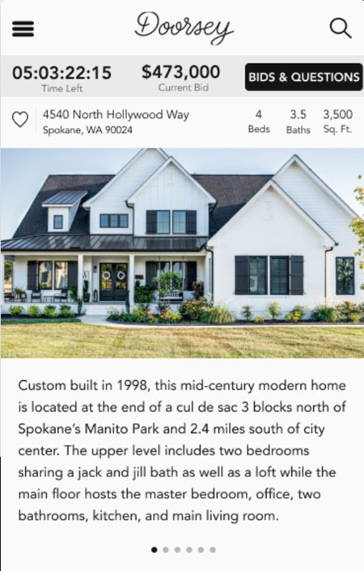

Before the age of the internet and e-commerce, you had to find what you wanted at a local store or dealer if you wanted to buy anything. The only information you had was what the salesperson told you about the item, or perhaps on a tag attached to the item you were shopping for.
For instance, if you bought a used car, you had little information about the vehicle and its history. Maybe it had a 30-day warranty. After that, if the car broke down and turned into a “lemon”, too bad, you were stuck with the purchase!
Today, you can buy nearly anything online, and it’s a whole different ballgame. As the eCommerce realm continues to grow and choices multiply, you can be as picky as you want when choosing who you want to buy from. And one of the primary factors that can influence your buying decision is: transparency. How much are they actually telling you about the product or service?
You want to feel like the eCommerce company you are buying from is fully transparent. This means giving you all the information you need to make an informed purchase – without playing a game of smoke and mirrors!
And transparency is not just good for you as a customer; it’s beneficial to businesses as well. Greater transparency leads to higher sales and more loyal, satisfied customers.

How Some Well-Known E-Commerce Companies Are Making The Buying Process Less Risky
Here are a few companies that have excelled at giving their customers more information - to create a better buying or selling experience:

Carvana – They have thought of nearly everything about buying a vehicle online. Here are some ways they are more transparent than your average car dealer:
- Each vehicle goes through a 105-point inspection before it’s listed for sale.
- They’ll only accept accident-free vehicles.
- Their “worry-free” warranty covers all mechanical assemblies for 100 days or 4189 miles after the purchase.
- A 7-day money-back guarantee makes it easy to return the car for any reason within the first seven days after delivery. Since you’re buying the vehicle sight unseen, this takes the risk out of not test-driving it first.
- Their free Carfax report gives the potential buyer transparency on any repairs or issues history.

Bring A Trailer – This is an online auction site for buying and selling classic and collector vehicles. They help support transparency in four ways:
- Their knowledgeable staff curates all vehicles, and they write honest and objective listings without a lot of superlatives. Plus, there’s an option for sellers to buy a professional photo portfolio for each listed vehicle.
- Each seller is provided with an Auction Specialist to guide him through the auction process.
- Every listing has a comment section where buyers can ask questions and get more information from sellers.
- The company has “sniping protection” during the auction, which extends the auction time by 2 minutes every time there’s a last-minute bid. So all buyers have more time to consider placing another bid.

Everlane – An E-commerce clothing company famous for its “Radical Transparency”. Here’s how they distinguish themselves:
- The company audits each factory they work with for factors such as reasonable hours, fair wages, and environmental responsibility. This openness establishes a higher level of trust from their customers.
- They construct their clothing items with the finest materials possible, so the pieces last for years.
- A transparent pricing model. They have a template that shows all costs to make their items, and illustrate how their retail markup is only about half of what other clothing retailers charge to consumers.

Old-Fashioned Homebuying Practices
Buying or selling residential real estate in the “old days” (and even now for the most part) was (and is) a time-consuming and stressful activity. Yes, you can view potential properties on your local MLS or other websites. But most listings have limited information, and you’ll always have more questions than answers.
Next, you call your real estate agent, who has to contact the listing agent to find these answers. If all seems satisfactory, you set up a time to view the property with your agent. Then you visit your potential future home, and if you like it, you have your agent write up a bid. And hope for the best! If your offer doesn’t “win”, chances are you’ll never know why. It may even be challenging to find out what the home eventually sold for!
The lack of transparency in this typical home buying process is obvious.

So How Does Doorsey Lower The Risks In Homebuying?
Doorsey offers a totally different model of buying and selling residential real estate. They have four top ways of making the process much more transparent than other real estate platforms:
1. Doorey’s most unique feature is its competitive online bidding platform. No more guessing whether your bid is high enough – you can see how it compares to other offers in real-time!
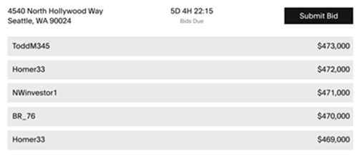

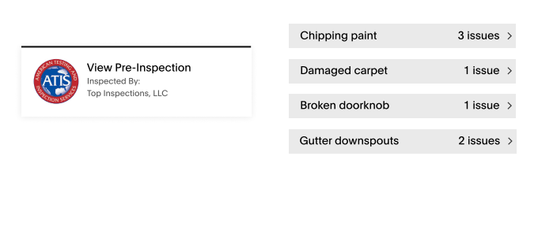
2. A free pre-offer inspection is included with each listing. It’s conducted by a licensed and bonded third-party inspector, eliminating surprises that could cause deals to fall through.

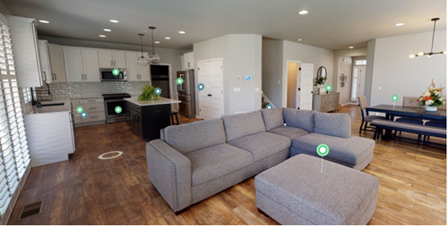
3. Matterport with mattertags. These virtual tours of listed properties add dozens of tags that call out appealing features in each room that buyers wouldn’t know about otherwise. This wealth of information can also add plenty of value for the seller.

4. A Q & A section where buyers can ask questions directly to the seller and get answers about the property. All parties can see these for even more visibility. 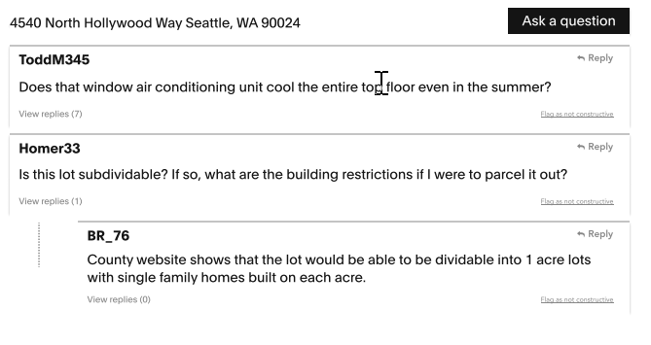

5. The sellers on Doorsey also win by showing their pre-defined seller’s terms right on the listing. That way, all buyers know precisely what the sellers require. If they agree with the terms, it becomes easier to compete on price alone.
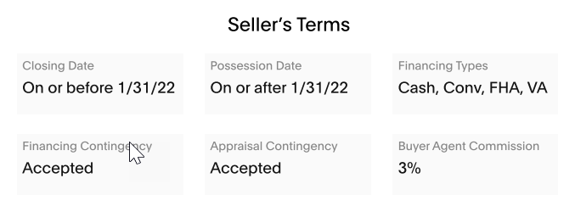

Of course, buyers can also easily schedule a viewing time on Doorsey to visit the property in person. That’s the ultimate in visibility!

If you’re a home buyer looking for residential real estate, you can begin to view Doorsey’s listings here.
Or, if you’re ready to sell your home on the best real estate platform available, you can submit your property here.

